Return Service Requested Non-Profit Organization
U S Postage Paid
Kosciusko, MS 39090
Permit No 94
T H E G O O D N E W S L E T T E R
First United Methodist Church
110-114 E. Washington, P. O. Box 1293, Kosciusko, MS 39090
(662) 289-1412 FAX (662) 289-1418 e-mail chur623@bellsouth
************************************************************************************************************
Learn the story. Live the story. Tell the story.

When I was a little boy, Mama used to make us check in once in a while. I thought at the time that was just a waste of good play time. But later I learned of the care and tenderness and love Mama shared with me in those times of ‘checkin’ in. Here is an e-mail a friend shared with me that stirred those memories:

“A minister passing through his church in the middle of the day, decided to pause by the altar and see who had come to pray. Just then the back door opened, a man came down the aisle, and the minister frowned as he saw the man hadn't shaved in a while. His shirt was shabby and his coat was worn and frayed, the man knelt, he bowed his head, then rose and walked away. In the days that followed, during each noon time, came this chap with a lunch pail on his lap, kneeling to pray for just a moment.
Well, the minister's suspicions grew, with robbery a main fear, he decided to stop the man and ask him, 'What are you doing here?' The old man said, he worked down the road. Lunch was half an hour. Lunchtime was his prayer time, for finding strength and power. 'I stay only moments, see, because the factory is so far away; as I kneel here talking to the Lord, this is kind a what I say: “I just came again to tell you, Lord, how happy I’ve been, since we found each other’s friendship and you took away my sin. Don’t know much of how to pray, but I think about you every day. So, Jesus, this is Jim checking in today.”
The minister feeling foolish, told Jim that was fine. He told the man he was welcome to come and pray just anytime… Time to go, “Thanks” Jim said smiling as he hurried to the door.
The minister knelt at the altar, he'd never done it before. His cold heart melted, warmed with love, and met with Jesus there. As the tears flowed, in his heart, he repeated old Jim's prayer: “I just came again to tell you, Lord, how happy I’ve been, since we found each other’s friendship and you took away my sin. Don’t know much of how to pray, but I think about you every day. So, Jesus, this is me checking in today.”
Past noon one day, the minister noticed that old Jim hadn't come. As more days passed without Jim, he began to worry some. At the factory, he asked about him, learning he was ill. The hospital staff was worried, but he'd given them a thrill. The week that Jim was with them had brought changes in the ward. His smiles, a joy contagious, and changed people, were his reward.
The head nurse couldn't understand why Jim was so glad, when no flowers, calls or cards came, not a visitor he had. The minister stayed by his bed, he voiced the nurse's concern: “No friends came to show they cared.” He had nowhere to turn. Looking surprised, old Jim spoke up and with a winsome smile; 'the nurse is wrong, she couldn't know, that he's in here all the while everyday at noon He's here, a dear friend of mine, you see, He sits right down, takes my hand, leans over and says to me:
“I just came again to tell you, Jim, how happy I have been, since we found this friendship, and I took away your sin. Always love to hear you pray, I think about you each and every day, and so Jim, this is Jesus checking in today.” (Copied)

Have you been checking in?

God’s Grace and Peace,
Br. Scott

P.S. What a great Camp Meeting Month we shared. Thank you to all of those who participated! It truly is great being your Pastor.

++++++++++++++++++++++++++++++++++++++++++++++++++++
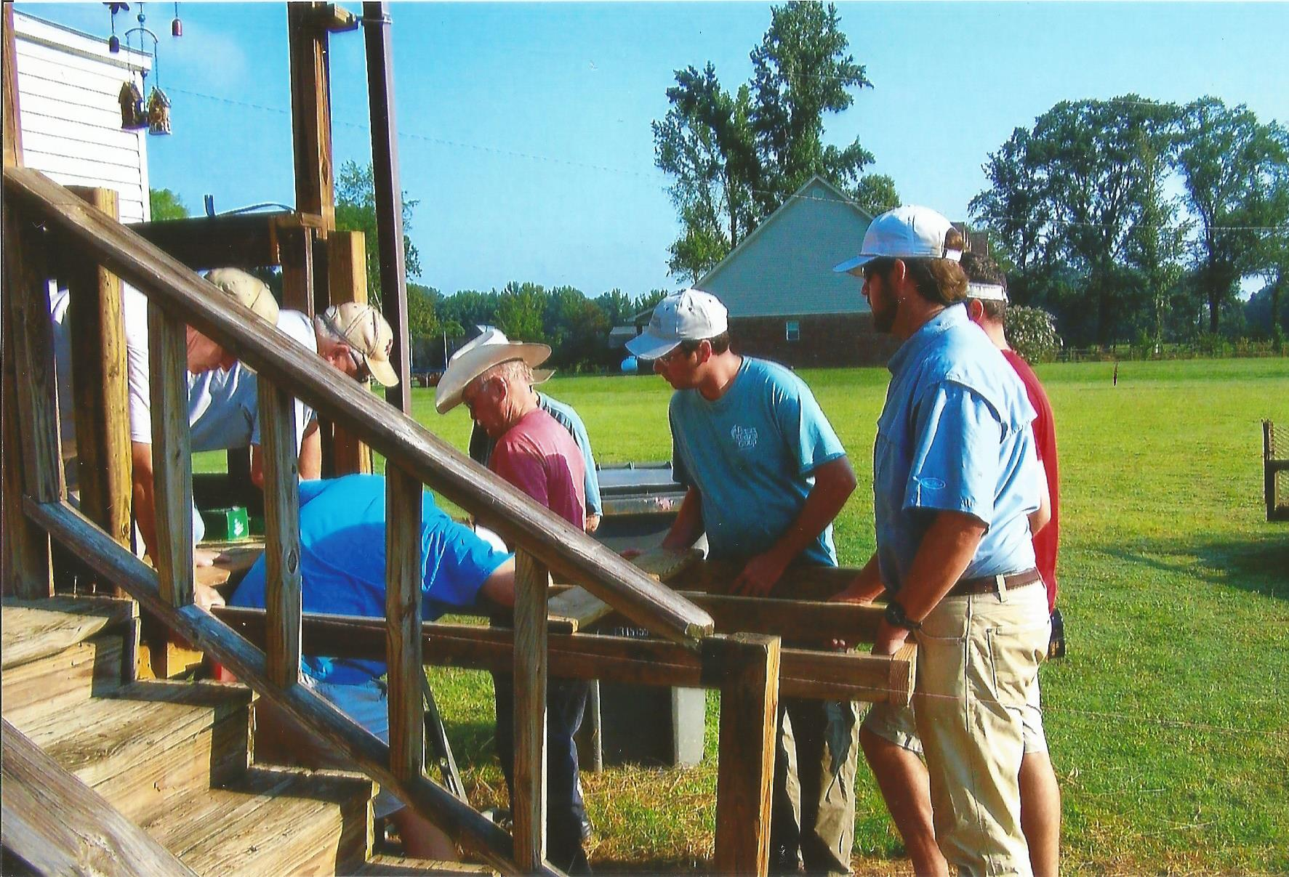
The Wild Bunch just completed their 28th ramp! This is a great mission providing handicap accessible wheel chair ramps to community members in need. Our church family funds these ramps if the family is unable and donations are always accepted. This project is generally completed in stages; home assessment,
building/assembly, and placement. Help is needed at each and every stage of the project. How can you help? If interested in participating in his wonderful service, please contact Tom Wasson at 662-739-0488. All are welcome!

+++++++++++++++++++++++++++++++++++++++++++++++
Financial report as of July 31, 2017

Budget for KFUMC 393,460.08
Total Rec. thru 7/31/17 173,605.68

Budget Tithes and Offerings 29,163.31
Budget Expenses 21,143.36
Mission Shares thru 7/31/17 23,304.01

Designated Funds Received:
Pastors Discretionary Fund 240.00
Chair Cushions 50.00
General Memorials 464.68
Youth 435.00
Youth Scholarship 100.00
Commercial Range 365.00
Sanctuary AC/Boiler 400.00
Mission Shares 400.00
African University Scholarship 422.17
++++++++++++++++++++++++++++++++++++++++++++++
Thank You!!!

Dear Hostess:
Thank you so much for throwing me a shower! I had so much fun, fellowshipping with everyone! Thank you for the hourglass and globe candle holder. They go great with our home décor. I am truly blessed with a great church family.
Jenna Pinkard

AFTER SCHOOL CARE
After School Care is off to a great start! We welcome Mrs. Mary Spears who will be teaching our Pre-K program. There are still a few openings and you can contact the church office if interested.
A very special thank you to those who volunteered the first few days of school:
Gail Pettit, Mickey Albin, Carolyn Campbell, Betsy Hutchison, Alicia Carter, Trish Cullen

A VIEW FROM THE PEW SEPTEMBER, 2017
By Peggy A. Keady

God’s Strategy
The recent and continuing unrest in our country caused me to search he scriptures for guidance.
I recalled a verse from the book of John declaring Satan’s intention toward human beings. It reads as follows: “The thief does not come except to steal and to kill and to destroy. I (Jesus) have come that they may have life and that they may have it more abundantly.” (John 10:10)
Since we know Satan’s goal, we can resist being drawn into the chaos he wishes to cause by filling our minds with God’s word, the Sword of the spirit.
Remember this is how Jesus gained victory over Satan in the wilderness. He answered each temptation with the Word of God.
We need to keep front and center in our minds that the things of this world pole in importance when compared with human beings, who are God’s creation.
We are commanded to love both our neighbors and our enemies. We are to desire their good even when we may not share their point of view. We are able to do this through the enabling power of the Holy Spirit who indwells every believer.

Family and friends are invited to a graveside service at Parkway Cemetery for
Mrs. Nora Hamaker
5:00pm, September 3, 2017. Immediately following join family to celebrate her life at Seasonings Restaurant.

Let us meet each day with love as our goal.
+++++++++++++++++++++++++++++++++++++++++++++++
NEW NAME FOR SUNDAY NIGHT
VESPERS
Starting September 10, 2017, 6:00 pm in the Chapel, Vespers will resume under a new name, “Bible Study”. The format of singing praises and prayers will continue, but the study of the Bible and other books will give inspiration for the week. The first book, “The Apostle” which is a deep study of the life of Paul will be led
by Dr. Ernie Flint.
++++++++++++++++++++++++++++++++++++++++++++++++++
You are cordially invited to the wedding of
Jenna Pinkard
And
Slaton King
September 2, 2017
1:00 in the afternoon
Upper Room
First United Methodist Church
Reception to follow in Parlor
+++++++++++++++++++++++++++++++++

Have you remembered the Endowment Fund in your offerings to FUMC?

Camp Lake Stephens fall events:

Children Spiritual Life Retreat September 23-24, 2017
Older Adult Trip to Ms. Gulf Coast October 17-20, 2017
Junior High Spiritual Life Retreat October 21-22
Sr. High Spiritual Life Retreat November 10-12
Overflow 2018 January 12-15, 2018
Confirmation Retreats: January 26-28, 2018 or February 2-4, 2018

+++++++++++++++++++++++++++++++++++++++++++++++

Dear Church Family,
It is with a heavy heart that I write this letter. Kosy FUMC has been my church home for over 42 years. I was raised and baptized at First Baptist but joined Kosy Methodist when I married Frank. After the passing of my mother it has become increasingly hard to sit by her vacant seat in Sunday School and to sit alone on “our” pew in morning worship. Sadness overwhelms me. After much prayer and talking with Brother Scott, I have decided that at this point in my life I need to return to the Baptist Church where I can worship with my children and grandchildren. My faith walk has been increased and enriched by so many of you and for this I am eternally grateful. I love each and every one of you and ask for your continued support and prayers.
Love in Christ,
Sissy Bailey

++++++++++++++++++++++++++++++++++++++++++++++++++++++++++++++++++
There will not be a Holiday Happening this year, but items that have been given for the Country Store will be offered for sale during the month of November, starting with Homecoming and All Saints Day on November 5, 2017.
++++++++++++++++++++++++++++++++++++++++++++++++++++++++++++++++++

The youth were very active this summer with a trip to Junaluska and a helping distribute school shoes at a local sports store as a mission project. Greg has planned many other activities throughout the coming school year.
++++++++++++++++++++++++++++++++++++++++++++++++++++++++++++++++++

Children resumed their activities on Wednesday nights for the month of August, and will start studies and music in the fall. The church is taking applications for a new children music director and activities director. Contact SPRC if interested.
++++++++++++++++++++++++++++++++++++++++++++++++++++++++++++++++++

Lunch Bunch trip to the Governor’s mansion was cancelled due to a bus problem, but Dot Harmon who has done an outstanding job in organizing these activities say that there will be another planned very soon.
++++++++++++++++++++++++++++++++++++++++++++++++++++++++++++++++++

Chancel Choir under the direction of Kevin Bishop will meet for practice on Sunday nights at 5:00 pm. He encourages anyone interested in joining the choir to come. They will be blessed with sharing their talent with the Sunday morning congregation.

