Return Service Requested Non-Profit Organization
U S Postage Paid Kosciusko, MS 39090
Permit No. 94

T H E G O O D N E W S L E T T E R
First United Methodist Church
110-114 E. Washington, P. O. Box 1293, Kosciusko, MS 39090
(662) 289-1412 FAX (662) 289-1418 e-mail chur623@bellsouth.net

*******************************************************************************************
Learn the story. Live the story. Tell the story.

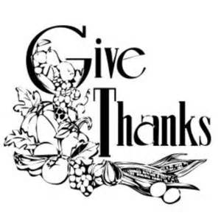
November 2015
*******************************************************************************************

“Going Home Again”
I have always heard that you can’t go home again. In my experience, it is in reference to how much we change over the course of our years. And…we can add that it also refers to how much a hometown changes over time.
In a few days, I will return to my hometown of Kosciusko. In the forty-six years since I left, I have changed and Kosciusko has changed, too. This journey back for me is the completion of a full circle. It is the embrace of what I received as a young lad from the people and the community life of First United Methodist Church in Kosciusko. It is the opportunity to offer my testimony of where my spiritual journey has led, and an acknowledgement that I have, at a much deeper level, come to the very place where I started.
In June of this year I retired after 47 years under appointment as a pastor in The Mississippi Conference of The United Methodist Church. It may be hard to believe but my last year was among, if not the best year of ministry for me.
I*n the final year as a District Superintendent, I participated in a ministry process offered by Spiritual Leadership, Incorporated. The SLI process of “loving, learning, and leading’ has been life giving in the core of my spiritual being. At the heart of the process is the Holy “Spirit’s work of transformation.
As I contemplated retirement, I experienced a tugging in my spirit. About the same time, I was captivated by the title of Jeri Sedlar’s book, Don’t Retire, Rewire! In the fall of 2-14, I was invited by the SLI to begin the process of becoming a Coach for their “Loving-Learning-Leading” process. Currently, I am serving as an SLI Apprentice.
I look forward to going home again. I will offer a series of three sermons on “Christian Love.” I will work with the Church Leadership in introducing the SLI process of “loving, learning, and leading.” And yes, the Holy Spirit is already at work preparing our hearts to receive its work in our midst.
Rev. John C. Moore

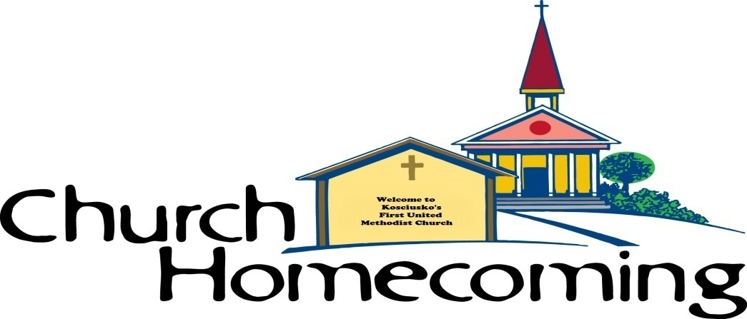
Join Us November 1st for our Homecoming Celebration at 10:55a and then a wonderful potluck meal to follow! We are also asking our Church Council to spend some invaluable time with Rev. Moore as we seek God’s will and discern His plan for our church!

Homecoming & Revival Meeting Schedule

Nov 1 10:55a Homecoming/All Saints Service
12:15p Potluck Lunch in Fellowship Hall
4 – 6p Church Council meets with Rev. Moore
6p Evening Worship – “What Ever Happened To Loving God?”

Nov 2 6p Evening Worship – “What Ever Happened To Loving Yourself”
7p Workshop with Church Council & Rev. Moore

Nov 3 6p Evening Worship – “What Ever Happened To Loving Your Neighbor”
7p Workshop with Church Council & Rev. Moore

*Nov 4 will be our regularly scheduled Wednesday night activities.
If you have any questions, please feel free to contact the church office at 662-289-1412.

FUMC ENDOWMENT FUNDS: Have you remembered the Endowment Fund in your will and Estate planning?

A View from the Pew by Peggy A. Keady November 2015
Choices Recently while waiting for a particular television program to begin, I watched the end of a Spiderman episode. I was struck by the following statement of truth made by the main character.
“It is the choices that make us who we are and we can always choose to do right.” How profound.
This brought to mind Joshua’s challenge to the people of Israel recorded in Joshua 24:14-15 NIV.
“Now fear the Lord and serve him with faithfulness. Throw away the gods your ancestors worshiped beyond the Euphrates River and in Egypt, and serve the Lord. But if serving the Lord seems undesirable to you, then choose for yourselves this day who you will serve, whether the gods your ancestors served beyond the Euphrates, or the gods of the Amorites, in whose land you are living. But as for me and my household, we will serve the Lord.”
It seems pretty plain that our decisions form our destiny. No wonder making wise choices is so important. When our wills are surrendered to Jesus Christ our thinking will be transformed and our choosing will be aimed toward what is right.
Take some time and think about some of the decisions that you made years ago and some you have made recently. Consider how they have impacted your life and the life of other people. What if you had chosen differently? What might have resulted?
Allowing the Holy Spirit to filter our thinking will enable us to always be assured of a choice that is pleasing to our loving Father. Let us choose wisely, thanking God as we do so.

We welcome our newest member, Mrs. Jana Alford, who comes by transfer of letter from Harmonia Methodist in Sallis.
The Halloween Carnival was one of the best yet. Several children went home with sacks full of treats and tummy’s full. It was fun for all ages as adults learned the fun of this celebration from coloring pictures to eating corn dogs, cotton candy and popcorn. A special thanks to everyone who helped for without you it would have not been a success...If you have Internet, check the fun out on the website and Face book.

Did You Know
Mic Lawrence was recently promoted to the rank of Major of the Ms. Highway Patrol, serving as the Chief Inspector of the Northern Enforcement Region consisting of Troops D, E, and F. His journey as a Trooper started with graduation in 1992 from the Ms. Highway Patrol Trooper School. Oktibbeha County was his first duty station serving Troop G. In 1997, he was assigned to Troop D for enforcement of Attala County and later was promoted to the rank of Master Sergeant to the Ms. Bureau of Investigation. In May of 2002, he was re-assigned to the enforcement division of Troop D as Assistant Troop Commander and then in 2005 was promoted to the rank of Lieutenant serving as the District Executive Officer of Troop D. 2013 brought the rank of Captain and then in September of 2015, he received this great honor for a job well done. Congratulations Mic!

Holiday Happening November 7, 8-1 pm
Several members of our church family have been very busy sorting and preparing items for Holiday Happening. This year there will be a, “Book” table, “Country Store”, “Christmas Table”, “Food Booth”, “Pictures with Rainbow”, “Specialty” items, “White Elephant” table and many more. This will be a fun day for the entire family. Make plans to come have sausage/biscuit, shop and then stay for the BBQ chicken plate. If you have not purchased your ticket for the chicken, there are tickets in the office. There is still time to bring your items, or make those one of a kind “Specialty” items that only can be purchased at this sale. The Food Booth items can be brought to the church on Friday Nov. 6, or early Saturday am. This needs to be an entire congregation event and will be lots of fun.

Cottage meetings have been fun and entertaining. Br. Scott has learned many things about our congregation. A scheduled meeting will be held at the home of Edwin Albin on November 10. Reminder cards will be sent. If you were not able to attend a previously planned meeting then come to the parlor on November 12 and 6:30 pm to meet with Br. Scott and Denise.

There is an interesting program for the Fall Fling at Camp Lake Stephens. Date is November 10, and the cost is $25. If you are interested in going information is in the office. The van or bus will not be going.

Veterans Day
5:30 pm on November 11. Our church will honor the Veterans from our church family as well as friends and family of the town and county with a special meal and program. If you are a Veteran or know of one not in our church family, please invite them. This is our way of saying “Thank you for your service.”

Helping Hands Holiday Tasting will be held on Friday, November 13 at the First Baptist Church Son Building from 11:00 to 1:30. Our church is responsible for a table, centerpiece and tasting foods. If you are interested in helping, please contact Mary Al Alford at 601-663-5825. Tickets are $10 and can be purchased in the church office or at the door. Please come enjoy and support a worthwhile mission, Helping Hands.

News of the Attala United Methodist Cluster

The Cluster churches, made up of Barlow, Buffalo, Kosciusko First, Marvin Chapel, Mt. Lebanon, and Mt. Vernon and Wesley, shared a delicious covered dish lunch at Barlow UMC at two o’clock on October 8,2015. Fourteen individuals were in attendance. The annual Christmas project of providing lotion for the residents of the Attala County Nursing Center was discussed and plans for implementation were put in motion. The next meeting will be on November 12, 2015 at Buffalo UMC at 2:00pm. Anyone interested in attending will be warmly welcomed.

Mission Shares Luncheon will be held on November 15, in the Fellowship Hall. The menu will be Chicken Lasagna with white sauce, Garden salad, special yeast rolls, and Carrot Cake. Be sure and make your reservations for this special meal.

Also that day the Church Council will meet at 12:45. If you have not finished eating, just pick up your plate and come to this meeting.

October 18, 2015
“What a nice surprise when Sunday dinner was delivered to our door! Doc and I thank the cooks and the delivery lady (Jeanenne Riecken) for the scrumptious meal. Also know that we are especially appreciative of your kind thoughts, phone calls, and prayers during this “speed bump” in our lives.
God Bless You. Doc. and Marianne Sistrunk

The deadline to submit information for the December GOODNEWS LETTER is, November 16.

Make plans to attend the annual Thanksgiving meal prepared by the wonderful cooks of FUMC November 18, at 5:30. Homebound meals will be delivered by the youth.
Cost of meal will be $6.00 adults, $3.00 children and $15.00 family.
This will be the last Wednesday night meal for 2015.

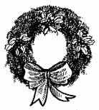
Community Thanksgiving will be November 22, at First Baptist Church at 6:00 pm. Br. Scott will be the speaker.

November 29 is the first Sunday of Advent. The devotional booklets will be ready and we will have a special “Hanging of the Greens” during our regular evening service to start this Season.

“Carols by Candlelight” will again be at the First Baptist Church in Jackson. Plans are being made for a group to attend on the Church bus. The date is December 12. Be sure and sign up.

~~~~~~~~~~~~~~~~~~~~~~~~~~~~~~~~~~~~~~~~~~~~~~~~~~~~~~~~~~~~~~~~~~~~~~~~~~
PLEDGE CARD: Please return by November 24th, 2015
Gracious God, you have given me the gifts of life, love, grace, and mercy. I know that through the cross you have pledged your life to me.
I pledge to you that I will give $_____________________ (yearly total) toward building Your Kingdom through First United Methodist Church for the Year 2016.
I will pay on this pledge on a weekly, monthly or quarterly basis. (Please circle one)
I also understand that your confidential servant who undertakes the financial accounting responsibilities for our church will be aware of this pledge and will send me reminders on a quarterly basis.
I, _________________________________________________ pray this in Jesus Name, Amen.
Date: _______________

